Development Guide
jWebSocket
Representation of data in real time through graphics using jWebsocket framework.
1.0

Versioning Control
Date | Version | Description | Autor
28/03/2012 | 1.0 | Preparing the document. | Merly López Barroso

- General Vision
The project's main objective is to increase the potential of the framework jWebSocket, providing new features that allow you to develop Web applications in real time to represent data graphically. To achieve this we developed an application that allows representing data in real time, providing greater security and usability.
- Infrastructure, Model, Approach
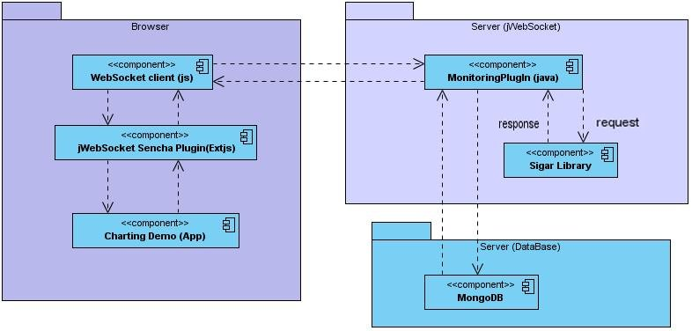

Image 1: This diagram describes the infrastructure Charting Demo
The Charting Demo application allows the graphical representation of real-time data developed with the frame jWebSocket. On the client side must run a browser that supports WebSocket protocol (remember: we have a Flash Fallback for older Browsers). The jWebSocket Client communicates through the WebSocket communication protocol with the jWebSocket server who is in charge of distributing the shares (you mean the resource data?) to be made; it contains a library SigarLibrary which is the component that provides the resources MonitoringPlugin machine. This in turn communicates with MongoDB, which interacts with the server to provide persistent data.
Among the design patterns used in the development of Charting Demo is the Observer pattern, which allows that when a user selects a new action, update the application so that other users logged can see the changes. Moreover Facade pattern was used in order to establish a common interface for all functions of the application.
Here one sentence per pattern what these are about will be interesting for the reader.
Charting Demo was developed using TokenPlugin. This is a lower-level structure where if you do not have many features and is easy to process messages, it is best to use since the application will benefit from increased performance.
- Requirements and prerequisites
The prerequisites for the continued development of the solution are:
- Database (MongoDB, any SQL DB, missing details here).
- Sigar?
- Connecting to the network

Configuring Maven
The JWebSocketMonitorigPlugIn module is configured via pom.xml file, an XML representation of the Maven project within the project folder to configure the dependencies and basic properties of the project.
This file contains various components of Maven, including maven-assembly-plugin, this allows you to export all sources jWebSocketMonitoringPlugin-1.0.jar file, bellow you will see how it is used:
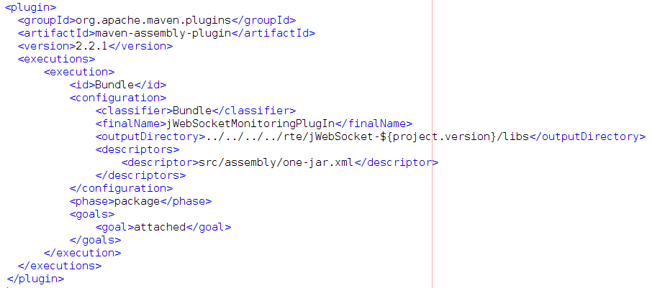

After compiling the project in the folder rte/jWebSocket-1.0/libs / are copied the fonts (fonts? What do you mean here) in the file jWebSocketMonitoringPlugIn-1.0.jar. How exactly is the interconnection with the Monitoring Plug-in? This is not clear to me here.
4. Modules, Structure
The main aspects that describe the organizational structure Charting Demo application are reflected below:
On the server side:
Project name: | Charting Demo
Location of the sources in the SVN server | http://10.208.7.203/svn/jwebsocket/trunk/Projects/jWebSocket/1.0/source-code/jWebSocketPlugIns/jWebSocketMonitoringPlugIn/  Don’t show your concrete IP’s here, use a placeholder like <svn_root>.
SVN branch: | jWebSocket-1.0
Maven dependencies: | 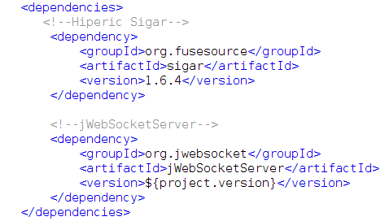
JAR module: | jWebSocketEventsPlugIn-1.0.jar
Package structure: | Based namespace:  jWebSocketMonitoringPlugIn  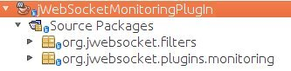
org.jwebsocket.filter: Contains a filter to register the plugins in use.
org.jwebsocket.plugins.monitoring:
Contains the plugin that implements all the functionality of the application and a listener to persist data in MongoDB.

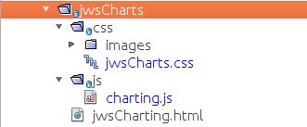
On the client side:
The client libraries and classes for Charting Demo application are available only to the JavaScript language and are stored in the folder germanyClient (?, use place holder here, we do not have such a folder in our SVN) / demos / jwsCharts.

On the client side file uses the following javascript:
- charting.js: Allows you to graph the data coming from the server.
It also uses htm and css file to the user interface of the application:
- jwsCharting.html: This file is set to any HTML application.
- jwsCharts.css: Includes the CSS for the HTML application.

- Source
The structure of the source code shown below:
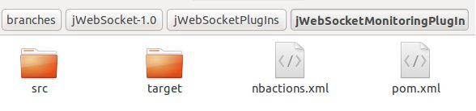
On the server side:
Description of elements:

- src: This directory contains all the source code of classes and libraries of the solution.
- target: This directory temporarily stores the compiled source code, its content is not included in the version control.
- nbactions.xml: project configuration file created by the NetBeans IDE. The contents of this file may or may not be in version control, to include depends on the decision of the development team.
- pom.xml: Configuration file for jWebSocketServer module that contains information about the project and details of the settings used by Maven to build the project.
On the client side:
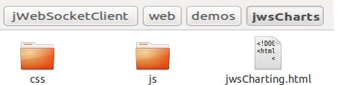

Description of elements:
- css: This directory contains the css file and a directory with the images used in the application.
- js: This directory contains the js file used for application development.
- jwsCharting.htm: A hypertext file. These are usually static content, not dynamic. Includes HTML application.
- What about the usage of jQuery? You should mention this requirement here
Standard code:
http://10.208.7.203/svn/proyecto/trunk/Thesis_Projects/Charting_Demo_Merly/Engineering/Plantilla Estandar de codigo.doc
What is this needed for? If required, please use englich and replace IP number by placeholder (e.g. <svn_server>)
Libraries and tools used
On the server side:
- Library Hyperic Sigar: version 1.6.4. Sigar is a gatherer and reporter system information, which provides data on the computer. It is also a multi-platform API that cross-language library and command-line tool can access the operating system and hardware level information in Java, Perl and NET.
- Please add MongoDB here too!
- Please add interconnection with Monitoring plug-in.
On the client side:
The libraries and classes for the extension MonitoringPlugin clients are available only for Java Script and are stored in the file jwsCharts.js. The requirements of external libraries in the client side are:

Library | Description
jWebSocket | JWebSocket client library for Java Script. LGPL License.
ExtJS | Version 4.0
No jQuery? | The demo looks like jQuery is used for the standard layout, no?

Plugin configuration monitoring.
This is part of the Administrator guide and should be moved to there!
The monitoring plugin settings can be managed in rte/jWebSocket-1.0/conf/jWebSocket.xml, where you can also configure other plugins. Below is the plugin configuration for jWebSocket:
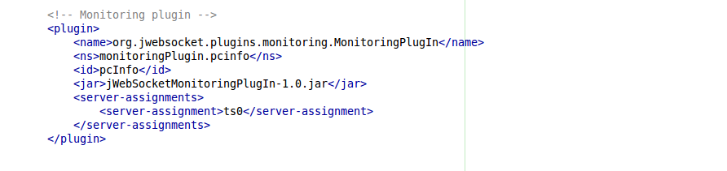

Detailed description of the application code

On the server side:

Org.jwebsocket.plugins.monitoring package consists of the following class, detailing the most significant methods.

Class MonitoringPlugIn:
processToken (): Receives incoming messages from any client WebSocket.
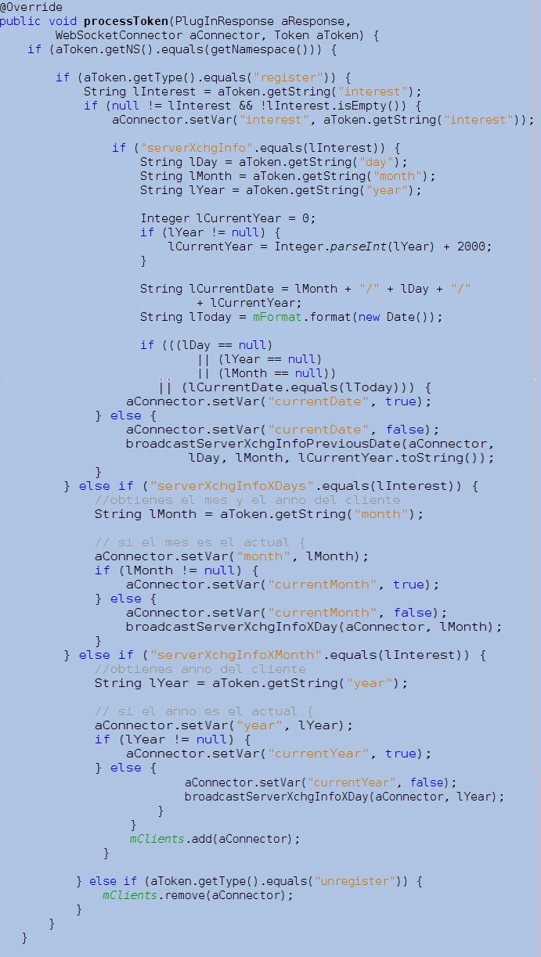

- broadcastServerXchgInfo(WebSocketConnector aConnector): Responsible for sending a token with the information requests that have been made ​​to the server in the current day.
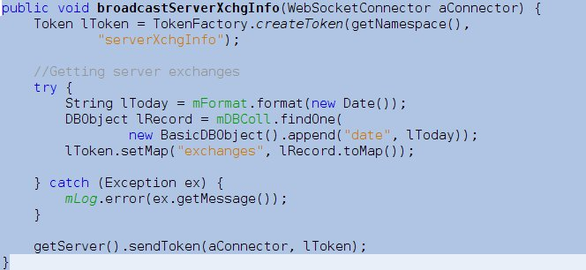

- broadcastServerXchgInfoPreviousDate(WebSocketConnector aConnector, String aDay, String aMonth, String aYear): Responsible for sending a token with the information requests that have been made ​​to the server as a selected day.

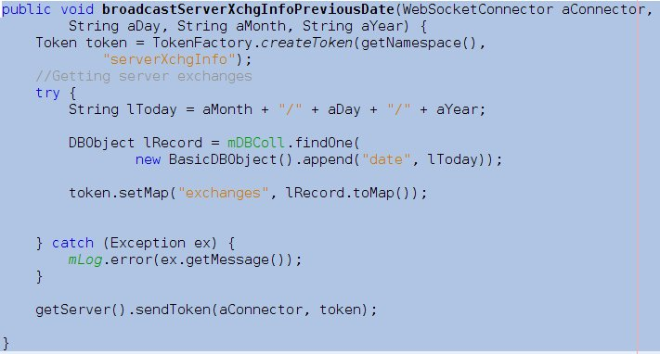

- broadcastPluginsInfo(WebSocketConnector aConnector): Responsible for sending a token with the information requests that have been made ​​to plugins that are in use.
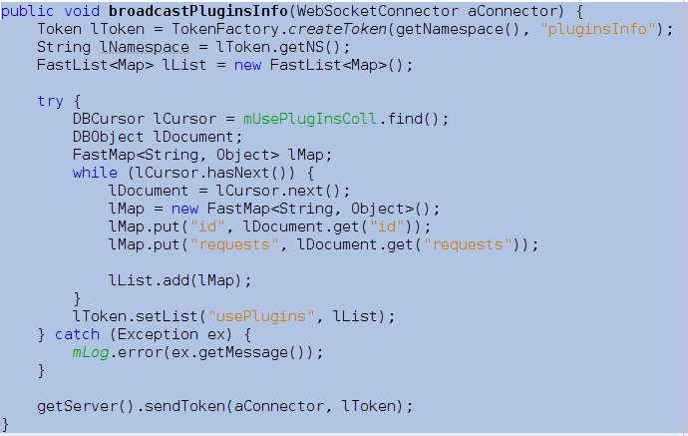

- computerInfoToToken(): Returns a token with the information of machine resources such as memory space used, free memory, total memory, swap usage, CPU consumption and total consumption.
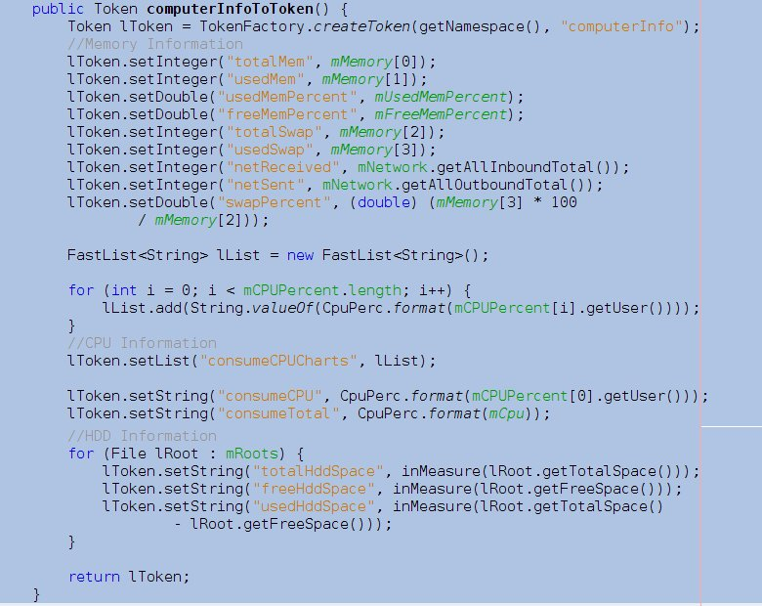

On the client side:

- plugin.processToken = function (aToken): The client contains a function which is responsible for processing all arriving token from the server and according to the type stores the information to then be displayed graphically.
- Interfaces (if applicable)
Network protocols used
The Charting Demo application was being developed on top of the jWebSocket framework, uses the WebSocket protocol (WS) to establish communication, a technology that provides a bidirectional communication channel and full-duplex over a single TCP socket. Also the plugin MonitoringPlugin.java application communicates with the Mongo database DB using the TCP protocol.

Programming Model
The Charting Demo is based on the doctrines of the event-driven programming, which is a programming paradigm in which both the structure and implementation of the programs are determined by events occurring in the system, defined by the user or they same cause.
- Frameworks, libraries and tools
For the development of the solution was used in the client side the EXT JS framework, which has a GNU (General Public License). It allows developing rich Internet applications (RIA).They are a new type of applications with more advantages than traditional Web applications. It’s used to display Web applications.
For the development of the solution was used Sigar library. It’s a library under the GNU GPL for obtaining data from our computer. It’s also a multi-platform API that through language library and command-line can access to the operating system tool and hardware level information in Java, Perl and NET.
Links/references?

Database and data persistence (if applicable)
The Charting Demo uses the Mongo document database DB. In this type of database you work with the collection terms, replacing the term entity of the relational database. A collection consists of a group of documents. It also uses the term document, which replaces the word tuple or row. The documents are composed of elements of key-value.
Use this database in order to keep track of the number of requests that are made to the server, so that element is stored as the actual date and the number of requests made for hours. This information is stored in the collection exchanges_server. On the other hand is recorded in addition the id of the plugins and the number of times is given to use each of them, this information is stored in the collection use_plugins.
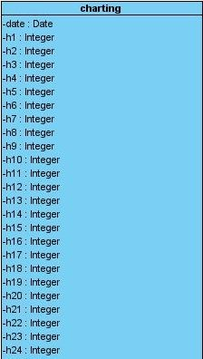

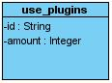
Whow, this table is a way to increasee the number of pages ;-)
H1-H24 could be gathered in a single line, what do you think?
H1..H24 / integer / Number of trades that you make to the server in the n(th) hour of the day.

Entity: | charting
Description: | This entity will contain the number of exchanges per hour than you do to your server 24 hours a day.
Relationships: | Not related to any other entity.
Fields | Data Type | Size | Description
date | date | - | Primary key containing the day you update your data.
h1 | integer | - | Number of trades that you make to the server in the first hour of the day.
h2 | integer | - | Number of trades that you make to the server in the second hour of the day.
h3 | integer | - | Number of trades that you make to the server in the third hour of the day.
h4 | integer | - | Number of trades that you make to the server in the fourth hour of the day.
h5 | integer | - | Number of trades that you make to the server in the fifth hour of the day.
h6 | integer | - | Number of trades that you make to the server at the sixth hour of the day.
h7 | integer | - | Number of trades that you make to the server in the seventh hour of the day.
h8 | integer | - | Number of trades that you make to the server in the eighth hour of the day.
h9 | integer | - | Number of trades that you make to the server at the ninth hour of the day.
h10 | integer | - | Number of trades that you make to the server in the tenth hour of the day.
h11 | integer | - | Number of trades that you make to the server at the eleventh hour of the day.
h12 | integer | - | Number of trades that you make to the server in time 12 of the day.
h13 | integer | - | Number of trades that you make to the server in time 13 of the day.
h14 | integer | - | Number of trades that you make to the server in time 14 of the day.
h15 | integer | - | Number of trades that you make to the server in time 15 of the day.
h16 | integer | - | Number of trades that you make to the server in time 16 of the day.
h17 | integer | - | Number of trades that you make to the server in time 17 of the day.
h18 | integer | - | Number of trades that you make to the server in time 18 of the day.
h19 | integer | - | Number of trades that you make to the server in time 19 of the day.
h20 | integer | - | Number of trades that you make to the server in time 20 of the day.
h21 | integer | - | Number of trades that you make to the server in time 21 of the day.
h22 | integer | - | Number of trades that you make to the server in time 22 of the day.
h23 | integer | - | Number of trades that you make to the server in time 23 of the day.
h24 | integer | - | Number of trades that you make to the server in time 24 of the day.

Please shorten this table!
Entity: | charting
Description: | This entity contains the id of the plugins used and its use is given.
Relationships: | Not related to any other entity.
Fields | Data Type | Size | Description
id | String | - | Primary key containing the id of the plugin.
amount | Integer | - | Use given to the plugin

- Hardware (if applicable)
Charting application Demo has no additional hardware required for its operation.
- Security
Let me know about the remaining work here please.
[En este epígrafe se describen todos los aspectos de seguridad de la solución. El enfoque de la seguridad en este epígrafe es más vinculado a la solución que a las configuraciones, que constituyen parte de la Guía del Administrador. Esta descripción se realiza teniendo en cuenta los siguientes elementos:
- Cómo se gestionan las credenciales, en base de datos o en otros servidores como Mail-Server o Twitter.
- Cómo se manejan las opciones de encriptación / SSL y cómo se usan las mismas para garantizar la seguridad de los usuarios
- Cómo se garantizan la privacidad de los datos de los usuarios.
- Cómo es protegida la solución ante el spam y los atques de agentes externos.
- Qué criterios de validación utiliza la solución y cómo lo hace
- Especificar el uso de filtros, listas blancas y negras, consideraciones sobre el firewall (puertos abiertos y/o protocolos)
- Qué otro mecanismo de seguridad ha sido aplicado o se considera se aplicará en el futuro.
- Qué problemas de seguridad de los conocidos en la actualidad no presenta la solución, o sea, han sido mitigados por los mecanismos de seguridad implementados para ella. Valorar si estos son aceptables para el uso de la solución en un ambiente de producción.
- Qué protección es posible utilizar para mejorar la seguridad de la solución y donde se pueden encontrar algunas opciones disponibles para ello.
- Testing, Quality Assurance and Integration Continues
[En este epígrafe se describe la ejecución de pruebas automatizadas y manuales para el aseguramiento de la calidad. Se incluirán también los elementos de integración continúa cuando estén definidos por el proyecto. Se mencionan a continuación los elementos a tener en cuenta para la descripción de este epígrafe:
- Describir los casos de pruebas, funcionales (JUnit, Jasmine) y de interfaz de usuario (iMacros, pendiente)
- Qué pruebas automatizadas están disponibles, cómo son estas invocadas, cómo están integradas estas pruebas dentro de la suite de pruebas de desarrollo de jWebSocket. Dónde se pueden encontrar informes o reportes al respecto.
- Diga si existen algunos problemas identificados durante el proceso de pruebas, cuáles son las razones de estos errores, están solucionados los mismos o qué soluciones alternativas se pueden hacer ante estos casos.
- Describa el manejo de los errores antes situaciones potenciales cómo, la base de datos no está disponible, la conexión de red falló, hay carencia de algún recurso necesario, entre otros casos.
- Cómo se manejan los errores de manera general y el tratamiento de excepciones.
- En caso de realizar pruebas manuales, especifique si estas puede realizarse antes de ejecutar la solución, especificar los detalles necesarios.
- Continuous improvement
[En este epígrafe se describe los métodos y estrategias tenidos en cuenta o que se proponen para la mejora continúa de la solución. Esta descripción se realiza teniendo en cuenta los siguientes aspectos:
- Diga si sigue la aplicación alguna estrategia para lograr mayor velocidad, menor consumo de memoria, hacer más simple el mantenimiento, etc.
- Proponga a su consideración posibles acciones que se pueden desarrollar para mejorar la solución desarrollada, ejemplo, utilizar como gestor de BD MongoDB y no MySQL ya que esto....

- References
[Este epígrafe constituye el lugar de consulta para desarrolladores, posee una correcta estructura y no utiliza texto, solo palabras claves en caso de que sean necesarias. Se exponen a continuación los elementos que componen este epígrafe:
- JavaDocs o JavaScriptDocs (documentación en línea) son obligatorios para su publicación (clases, constantes, variables, métodos, argumentos, ejemplos de resultados, las propiedades, las banderas), todas las clases y métodos en todos los idiomas deben estar completamente documentados para la eficaz gestión del conocimiento y el mantenimiento.
- Hacer referencia a otra documentación generada automáticamente además de los JavaDocs o JavaScriptDocs para su distribución en línea. No es necesario que copie esta documentación en la Guía del Desarrollador, solo ponga la referencia a esta documentación.
- Especificar la referencia de Tokens, vea ejemplo en Channel Documentation en la Web de JweSocket.
- Lista de otros archivos, siempre que no estén generados automáticamente por un instrumento de documentación en línea, al igual que JavaDocs. (por ejemplo, un determinado conjunto de archivos de configuración y su propósito), para los archivos de configuración, especifique la lista de configuraciones y posibles opciones. Esto también es importante para el empaquetado y el despliegue de la solución.

